The above data is input in SAS data set and dummy variables are created as shown below:

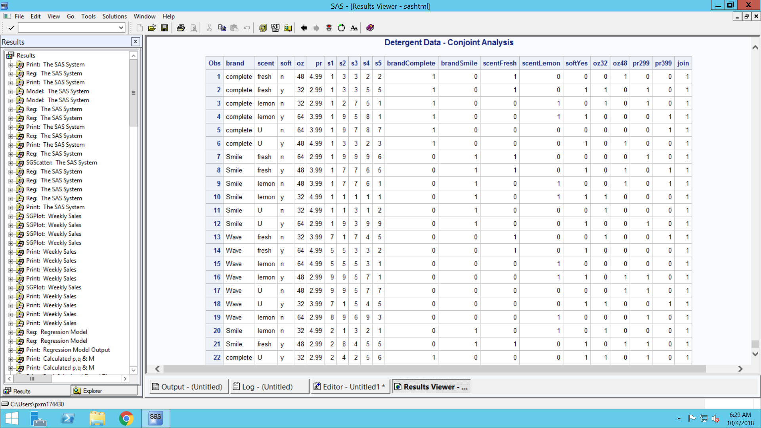

Regression Model co-efficient for each respondent (s1-s5):

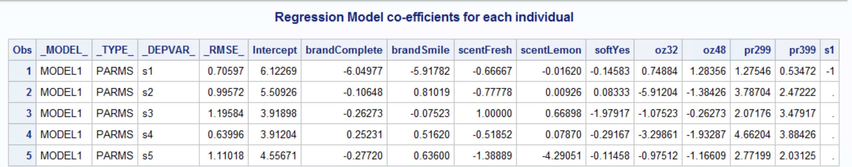

1. *Find the importance weights and part-worths for each respondent.*

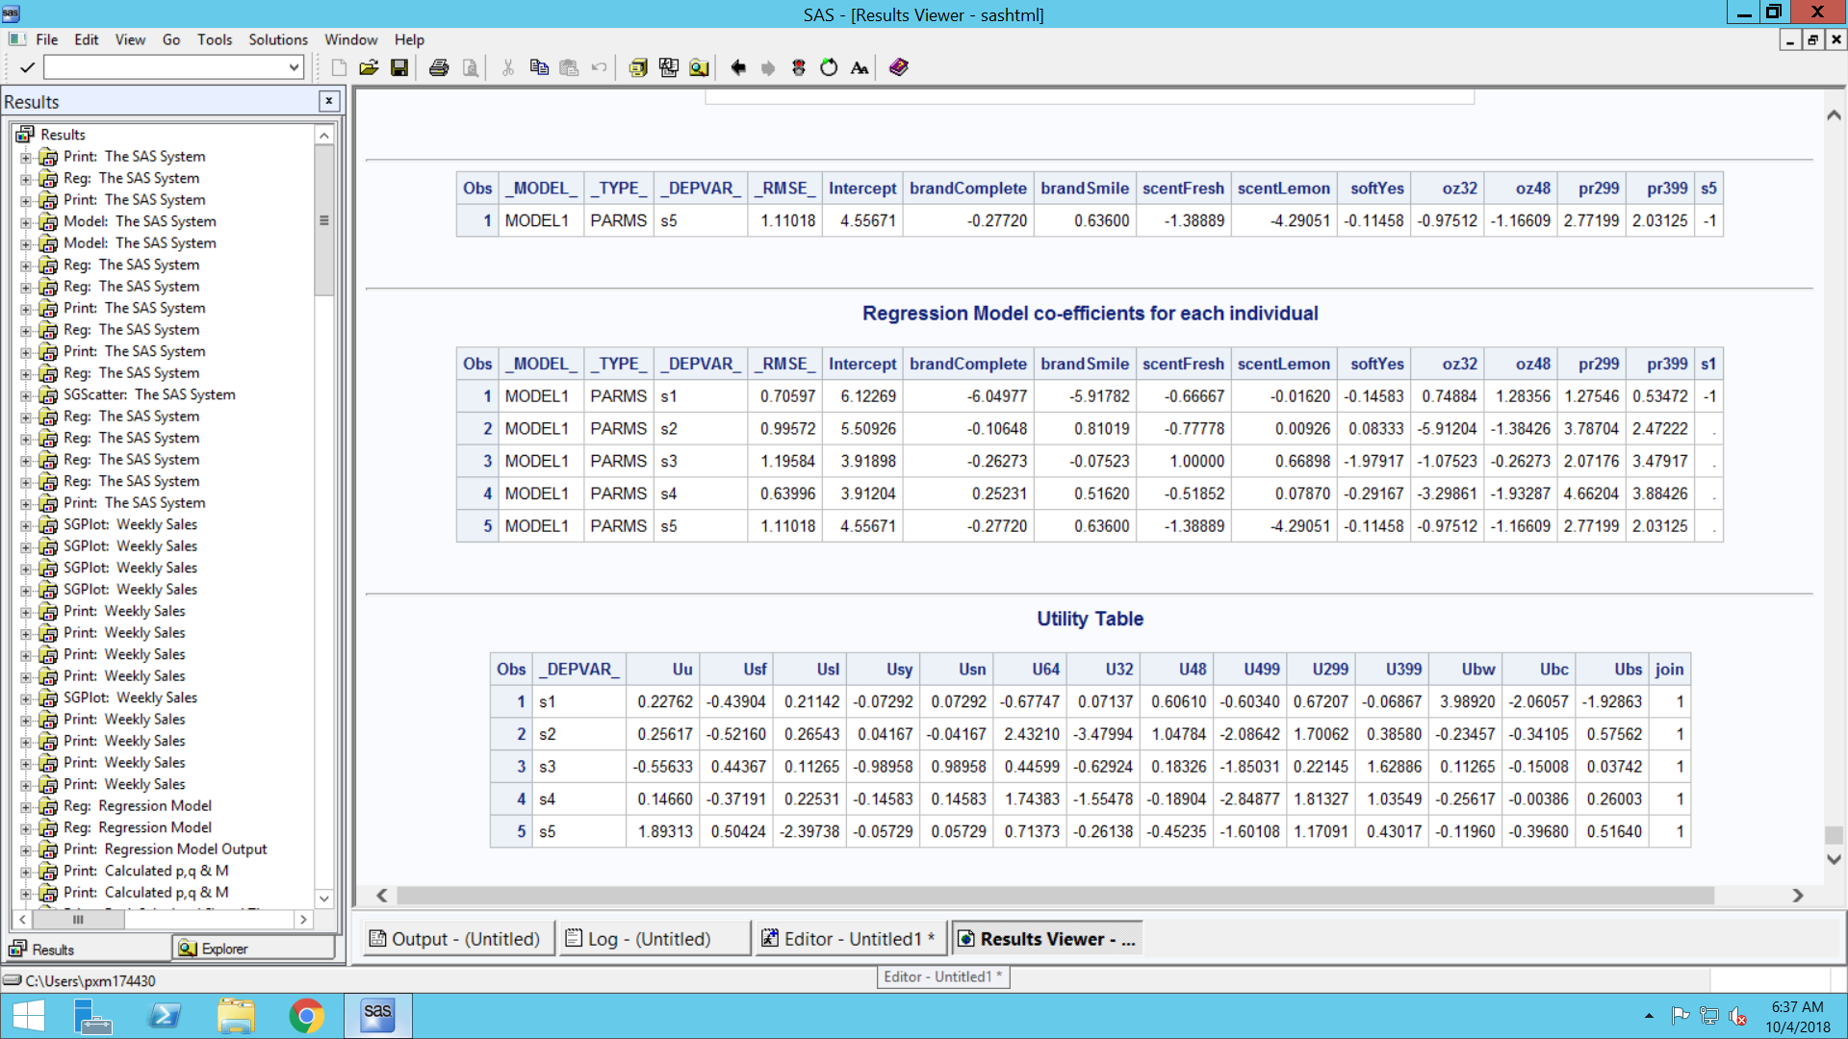

The relative importance calculations for all the respondents:

|  |  |  |  |  |
| --- | --- | --- | --- | --- |
| **For S1:** |  |  |  |  |
| **Attribute** | **Level** | **Utility** | **Max-Min** | **Relative Importance** |
| Brand | Complete | -2.061 | 6.05 | 0.642195992 |
|  | Smile | -1.929 |  |  |
|  | Wave | 3.989 |  |  |
|  |  |  |  |  |
| Scent | Fresh | -0.439 | 0.667 | 0.070800781 |
|  | Lemon | 0.211 |  |  |
|  | Unscented | 0.228 |  |  |
|  |  |  |  |  |
| Softener | Yes | -0.0729 | 0.1458 | 0.015476393 |
|  | No | 0.0729 |  |  |
|  |  |  |  |  |
| Size | 32 | 0.0713 | 1.283 | 0.13618801 |
|  | 48 | 0.606 |  |  |
|  | 64 | -0.677 |  |  |
|  |  |  |  |  |
| Prize | 299 | 0.672 | 1.275 | 0.135338825 |
|  | 399 | -0.068 |  |  |
|  | 499 | -0.603 |  |  |
| Total | |  | 9.4208 |  |

**For S2:**

|  |  |  |  |  |
| --- | --- | --- | --- | --- |
| **Attribute** | **Level** | **Utility** | **Max-Min** | **Relative Importance** |
| Brand | Complete | -0.34105 | 0.91667 | 0.079806758 |
|  | Smile | 0.57562 |  |  |
|  | Wave | -0.23457 |  |  |
|  |  |  |  |  |
| Scent | Fresh | -0.5216 | 0.78703 | 0.068520092 |
|  | Lemon | 0.26543 |  |  |
|  | Unscented | 0.25617 |  |  |
|  |  |  |  |  |
| Softener | Yes | 0.04167 | 0.08334 | 0.007255714 |
|  | No | -0.04167 |  |  |
|  |  |  |  |  |
| Size | 32 | -3.47994 | 5.91204 | 0.514711669 |
|  | 48 | 1.04784 |  |  |
|  | 64 | 2.4321 |  |  |
|  |  |  |  |  |
| Prize | 299 | 1.70062 | 3.78704 | 0.329705767 |
|  | 399 | 0.3858 |  |  |
|  | 499 | -2.08642 |  |  |
| Total | |  | 11.48612 |  |
|  |  |  |  |  |
| **For S3:** |  |  |  |  |
| **Attribute** | **Level** | **Utility** | **Max-min** | **Relative Importance** |
| Brand | Wave | 0.11265 | 0.26273 | 0.033699362 |
|  | Complete | -0.15008 |  |  |
|  | Smile | 0.03742 |  |  |
|  |  |  |  |  |
| Scent | Unscented | -0.55633 | 1 | 0.128266137 |
|  | Fresh | 0.44367 |  |  |
|  | Lemon | 0.11265 |  |  |
|  |  |  |  |  |
| Softener | Yes | -0.98958 | 1.97916 | 0.253859207 |
|  | No | 0.98958 |  |  |
|  |  |  |  |  |
| Size | 64 | 0.44599 | 1.07523 | 0.137915598 |
|  | 32 | -0.62924 |  |  |
|  | 48 | 0.18326 |  |  |
|  |  |  |  |  |
| Prize | 499 | -1.85031 | 3.47917 | 0.446259695 |
|  | 299 | 0.22145 |  |  |
|  | 399 | 1.62886 |  |  |
| Total | |  | 7.79629 |  |
|  |  |  |  |  |
|  |  |  |  |  |
| **For S4:** |  |  |  |  |
| **Attribute** | **Level** | **Utility** | **Max-Min** | **Relative Importance** |
| Brand | Wave | -0.25617 | 0.5162 | 0.055115832 |
|  | Complete | -0.00386 |  |  |
|  | Smile | 0.26003 |  |  |
|  |  |  |  |  |
| Scent | Unscented | 0.1466 | 0.59722 | 0.063766519 |
|  | Fresh | -0.37191 |  |  |
|  | Lemon | 0.22531 |  |  |
|  |  |  |  |  |
| Softener | Yes | -0.14583 | 0.29166 | 0.031141192 |
|  | No | 0.14583 |  |  |
|  |  |  |  |  |
| Size | 64 | 1.74383 | 3.29861 | 0.352199989 |
|  | 32 | -1.55478 |  |  |
|  | 48 | -0.18904 |  |  |
|  |  |  |  |  |
| **Prize** | 499 | -2.84877 | 4.66204 | 0.497776468 |
|  | 299 | 1.81327 |  |  |
|  | 399 | 1.03549 |  |  |
| Total | |  | 9.36573 |  |

**For S5:**

|  |  |  |  |  |
| --- | --- | --- | --- | --- |
| **Attribute** | **Level** | **Utility** | **Max-Min** | **Relative Importance** |
| Brand | Wave | -0.1196 | 0.9132 | 0.098656491 |
|  | Complete | -0.3968 |  |  |
|  | Smile | 0.5164 |  |  |
|  |  |  |  |  |
| Scent | Unscented | 1.89313 | 4.29051 | 0.463520217 |
|  | Fresh | 0.50424 |  |  |
|  | Lemon | -2.39738 |  |  |
|  |  |  |  |  |
| Softener | Yes | -0.05729 | 0.11458 | 0.012378516 |
|  | No | 0.05729 |  |  |
|  |  |  |  |  |
| Size | 64 | 0.71373 | 1.16608 | 0.125976086 |
|  | 32 | -0.26138 |  |  |
|  | 48 | -0.45235 |  |  |
|  |  |  |  |  |
| Prize | 499 | -1.60108 | 2.77199 | 0.29946869 |
|  | 299 | 1.17091 |  |  |
|  | 399 | 0.43017 |  |  |
| Total | |  | 9.25636 |  |

**Cross-checking the utility values using TRANSREG:**

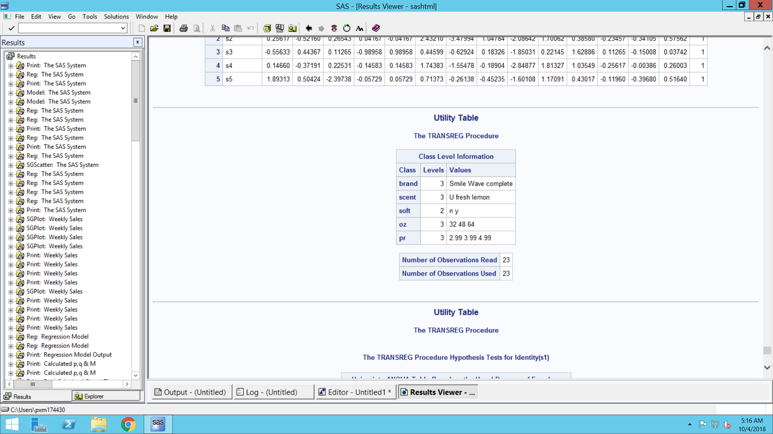

**For S1:**

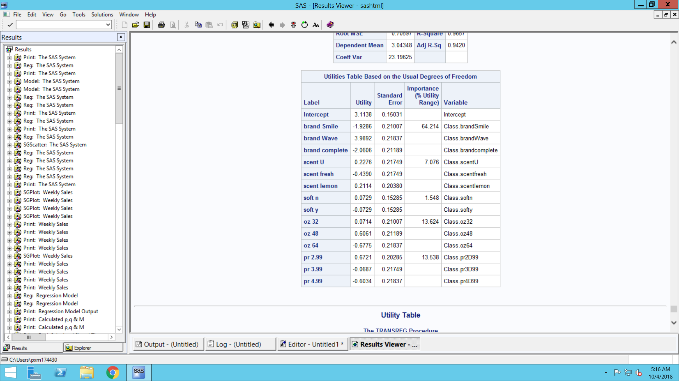

**For S2:**

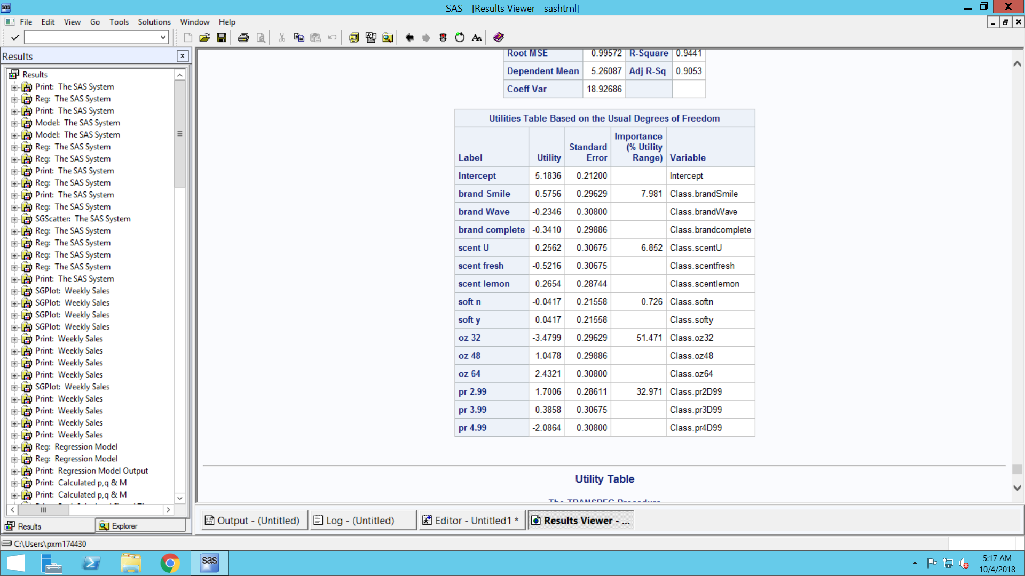

**For S3:**

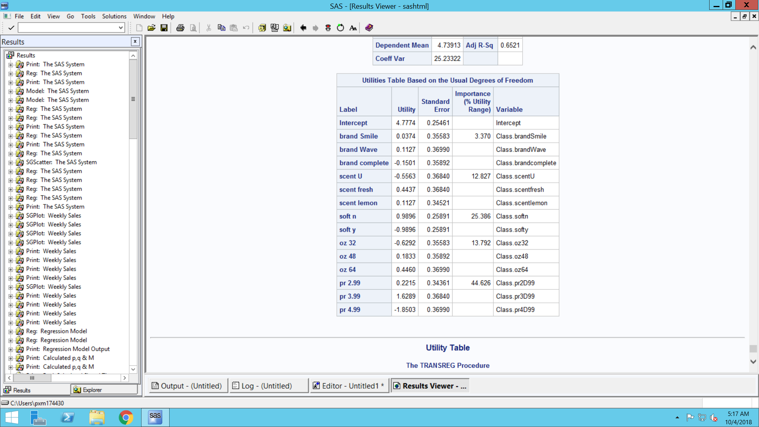

**For S4:**

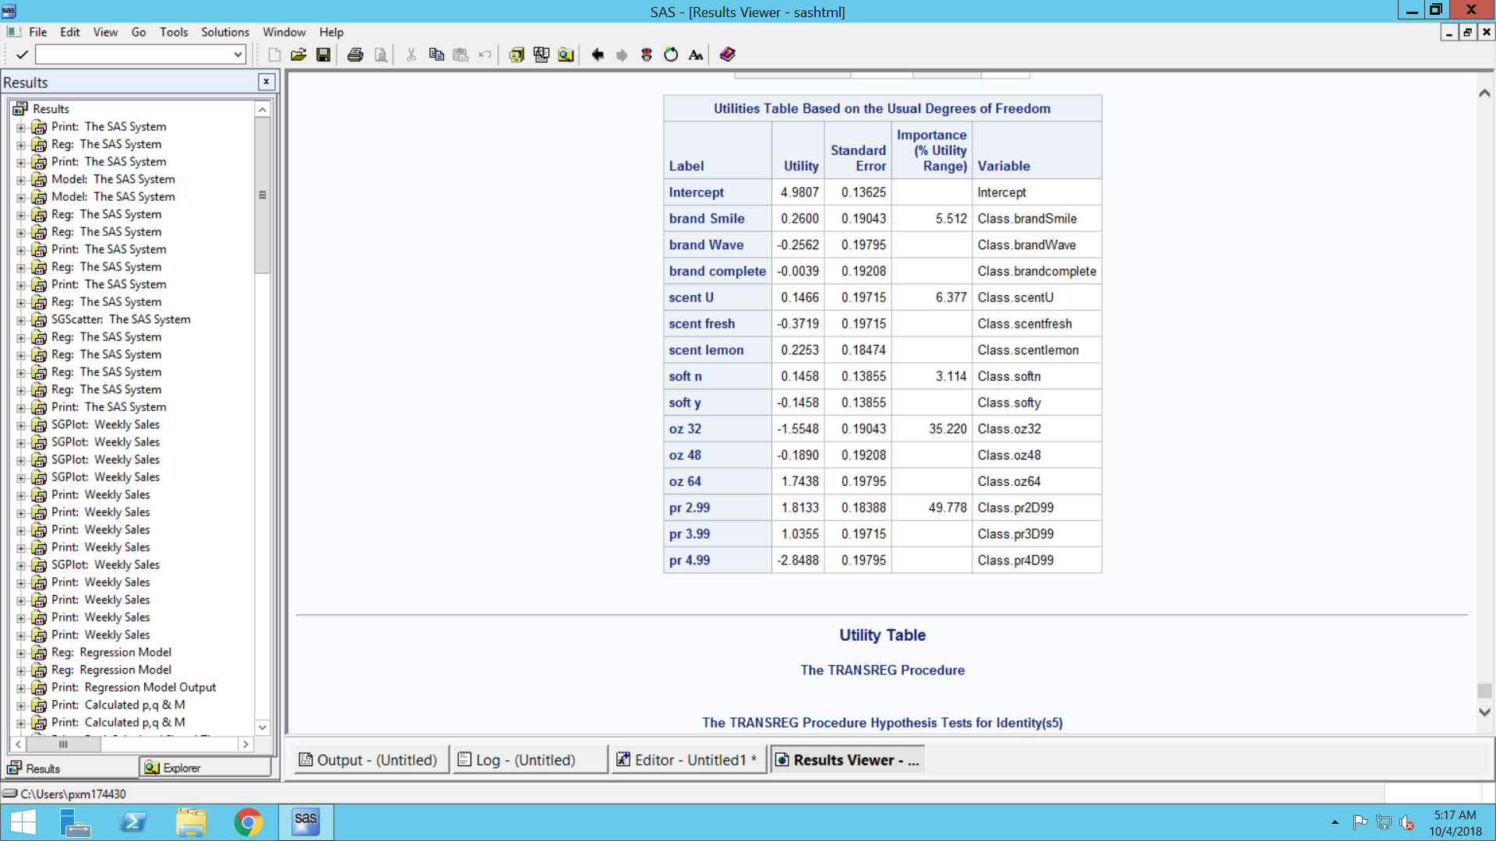

**For S5:**

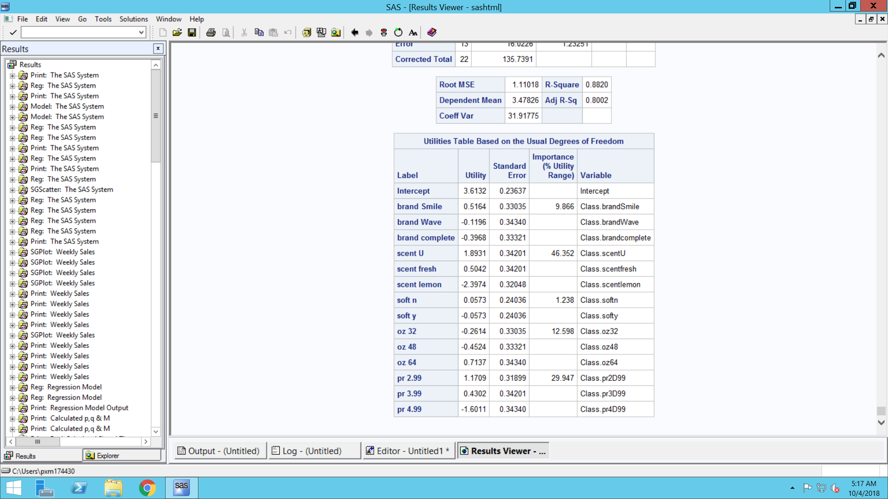

If you compare the output obtained from the proc transreg procedure and the one obtained by following the step by step procedure, the results turned out to be exactly the same. Hence, we can say the procedure that has been followed is correct.

1. *Predict the choice (using logit rule) for each respondent (s1-s5) for each of the following combinations using your estimates in question 1 above.*

|  |  |  |  |  |  |  |  |  |  |
| --- | --- | --- | --- | --- | --- | --- | --- | --- | --- |
| complete | lemon | y | 64 | 2.99 |  |  |  |  |  |
| Smile | fresh | y | 48 | 2.99 |  |  |  |  |  |
| Smile | u | y | 48 | 3.99 |  |  |  |  |  |
| Wave | u | y | 48 | 2.99 |  |  |  |  |  |
| Smile | u | n | 48 | 2.99 |  |  |  |  |  |

**ANSWERS:**

We input data for prediction in SAS

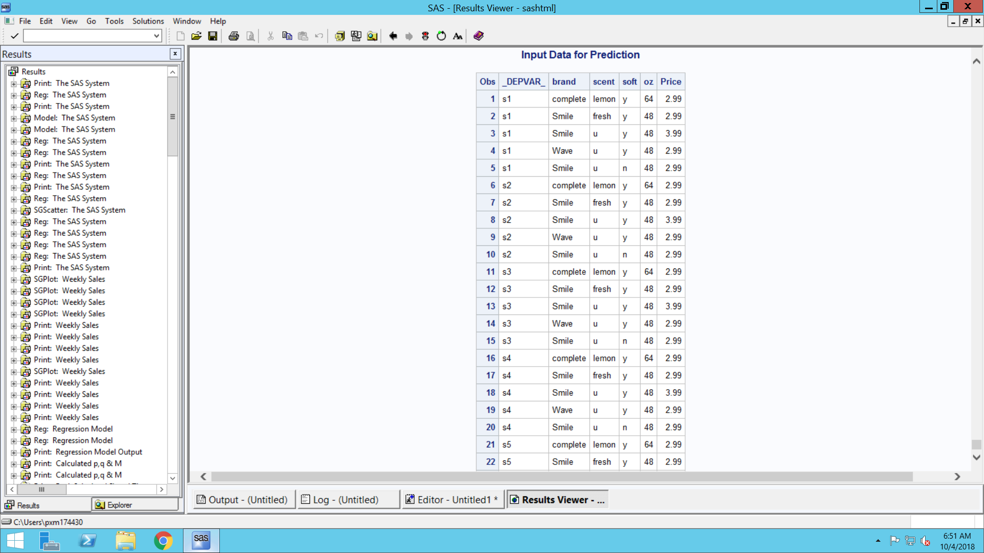

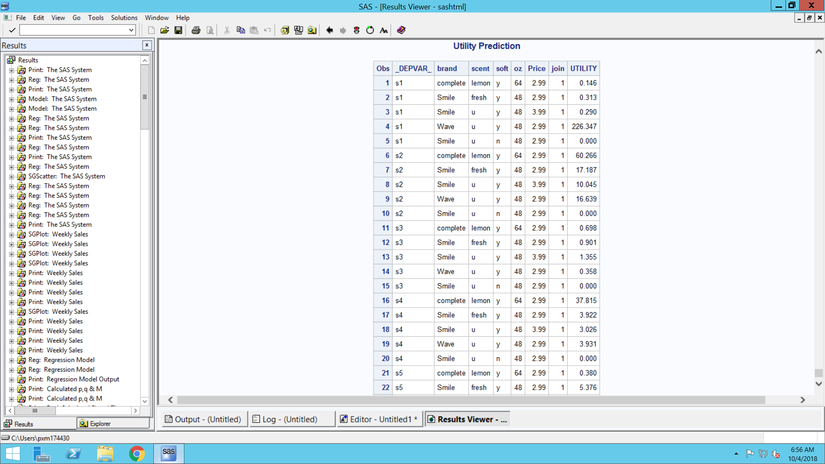

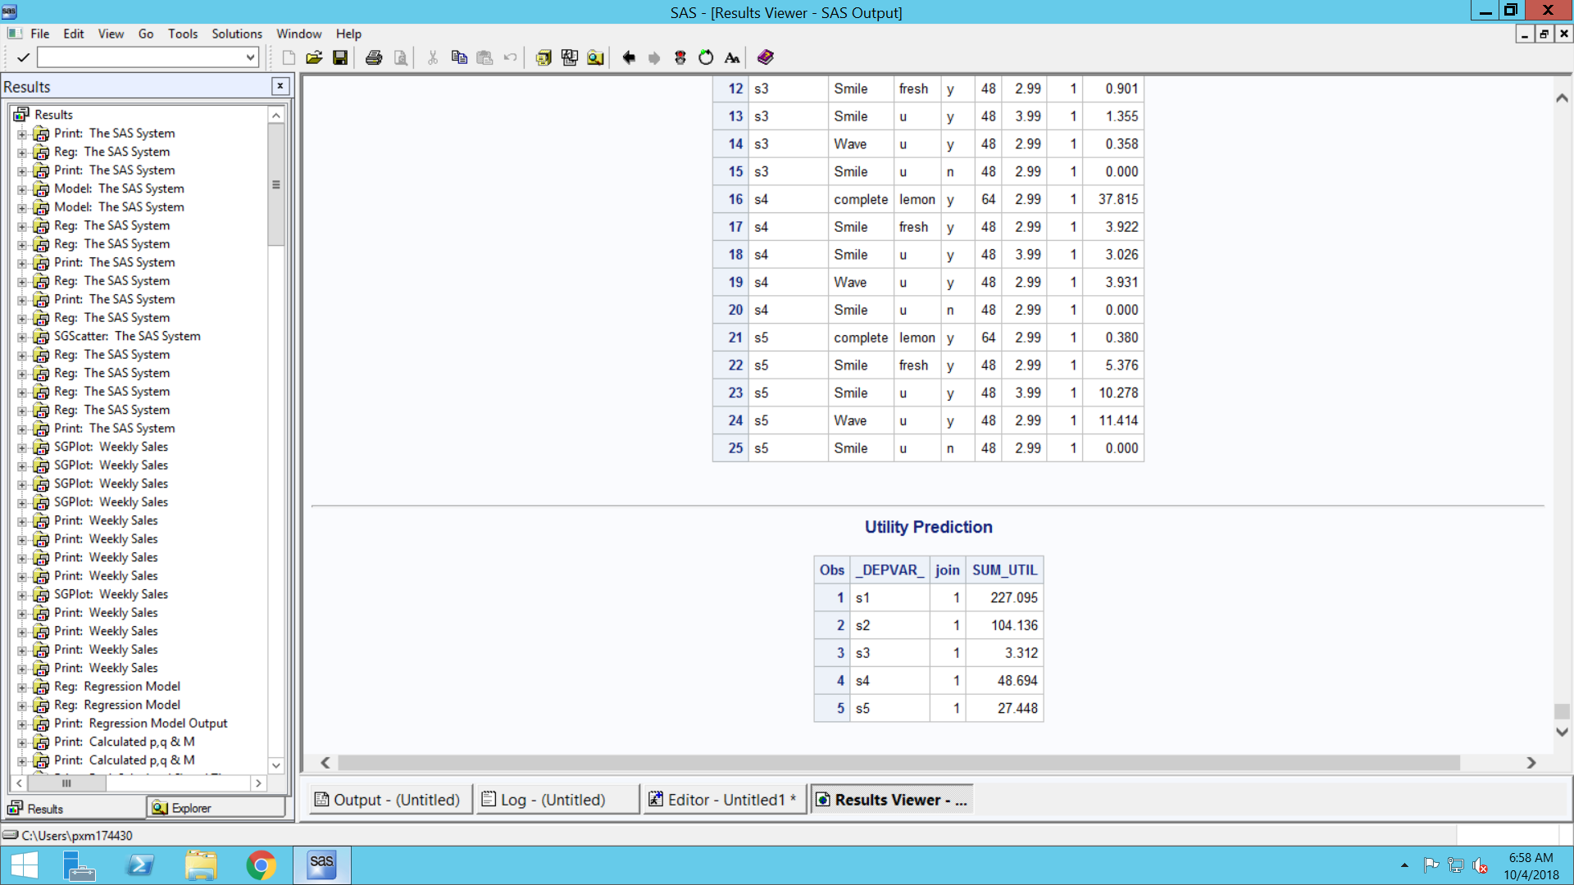

/*Logit rule probability calculations*/

**DATA** HW3.Util;

SET HW3.Predict;

MERGE HW3.Predict HW3.SumUtil;

BY _DEPVAR_;

Probability=UTILITY/SUM_UTIL;

**run**;

**PROC** **PRINT** DATA=HW3.Util; **RUN**;

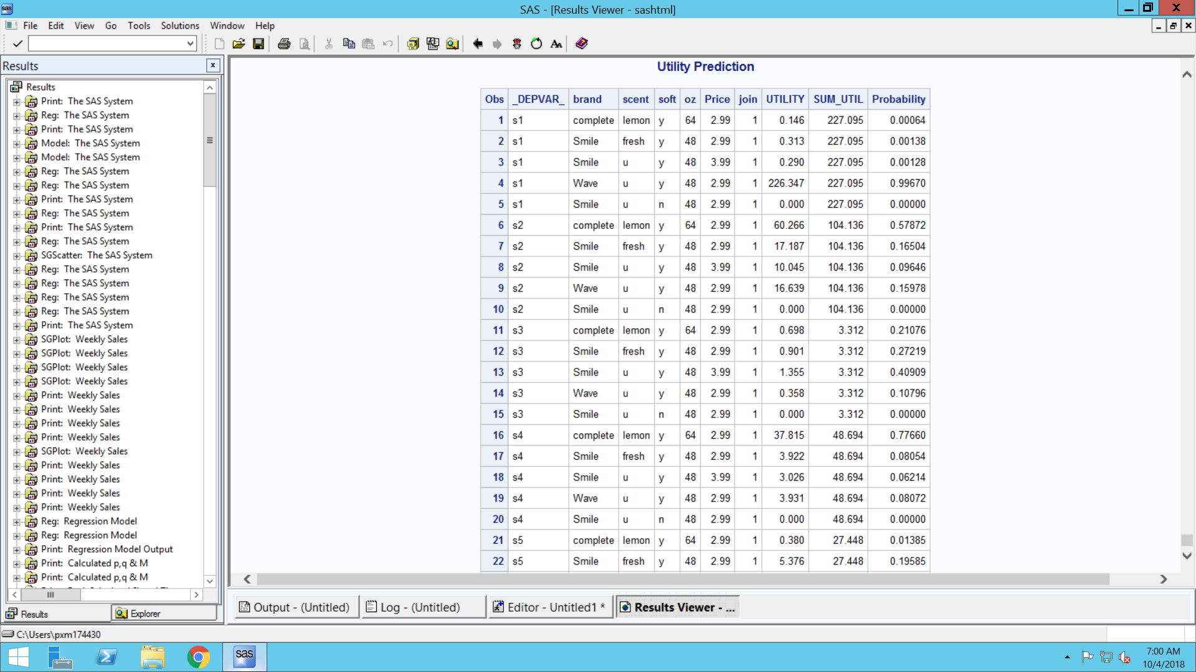

**The summarized output is as follows:**

|  |  |  |  |  |  |  |  |  |  |
| --- | --- | --- | --- | --- | --- | --- | --- | --- | --- |
| **Brand** | **Sent** | **Soft** | **Oz** | **Price** | **S1** | **S2** | **S3** | **S4** | **S5** |
| complete | lemon | y | 64 | 2.99 | 0.00064 | **0.57872** | 0.21076 | **0.7766** | 0.01385 |
| Smile | fresh | y | 48 | 2.99 | 0.00138 | 0.16504 | 0.27219 | 0.08054 | 0.19585 |
| Smile | u | y | 48 | 3.99 | 0.00128 | 0.09646 | **0.40909** | 0.06214 | 0.37447 |
| Wave | u | y | 48 | 2.99 | **0.9967** | 0.15978 | 0.10796 | 0.08072 | **0.41582** |
| Smile | u | n | 48 | 2.99 | 0.0000 | 0.00000 | 0.00000 | 0.00000 | 0.00000 |

From the above logit rule table we observed that the preferred choices for each individual are as follows::

1. S1: Brand-**Wave**; Scent-**Unscented**; Soft-**Y**; Oz-**48**; Price-**2.99**
2. S2: Brand-**Complete**; Scent-**Lemon**; Soft-**Y**; Oz-**64**; Price-**2.99**
3. S3: Brand-**Smile**; Scent-**Unscented**; Soft-**Y**; Oz-**48**; Price-**3.99**
4. S4: Brand-**Complete**; Scent-**Lemon**; Soft-**Y**; Oz-**64**; Price-**2.99**
5. S5: Brand-**Wave**; Scent-**Unscented**; Soft-**Y**; Pz-**48**; Price-**2.99**

Most Preferred choice among the given 5 combinations:

**PROC** **SORT** DATA=HW3.Util; BY brand scent soft oz Price ; **RUN**;

TITLE 'Most Preferred combination';

**PROC** **MEANS** MEAN ; VAR Probability; CLASS brand scent soft oz Price; **RUN**;

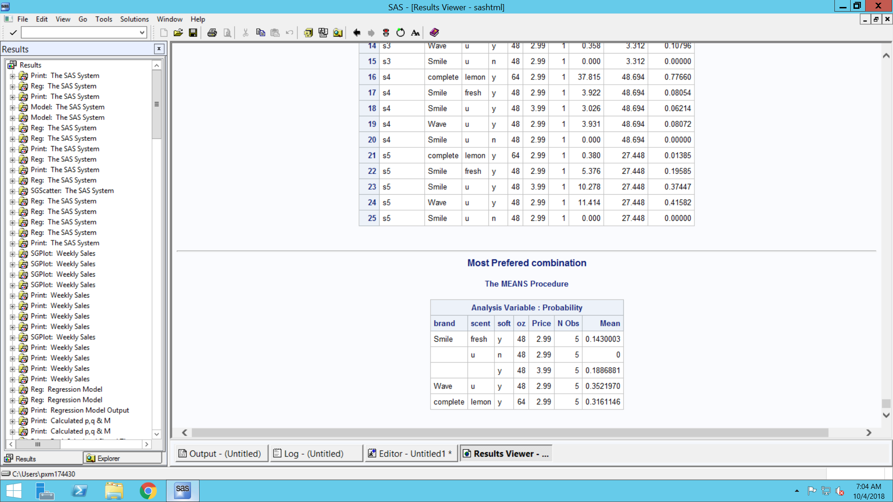

From the above output we can say that the following combination is the most popular detergent choice among given 5.

Brand-**Wave**; Scent-**Unscented**; Soft-**Y**; Pz-**48**; Price-**2.99**